Feedback 22.03.2026
Yellow highlights not implemented from last feedback
Non-highlighted = updates
__________________________________
- Move allergens to the bottom below macros. Make them “ – “ separated. Not chips. Just words
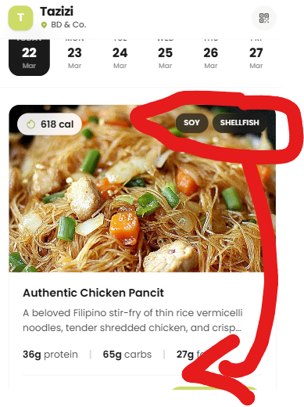

- Switch Cal with Protein macro
- Add weight macro to the top right where currently the allergens are in chip format

- Let us use our categories: Bowls, Salads, Wraps/Sandwich, Snacks
  - Add them below the date. Freeze to the top
- Is it sending branded confirmation email? It should send from hello@tazizi.ae
- Lets add at the top between the location and the day / dates row an instruction text “Pre-order by 5 PM for next-day pickup from your Tazizi fridge.”
- Remove the clear all button
  - 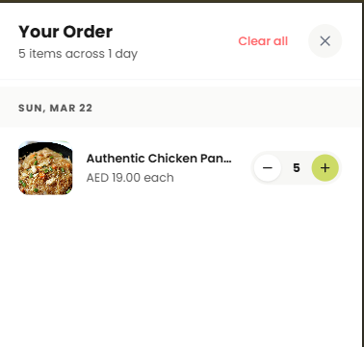
- Can we somehow freeze the date when scrolling down (maybe not the entire row but just the current date) so when scrolled down, people know for which day they add the meal
- Remove T icon and replace Tazizi word with Tazizi logo
- 


When you click on location, the QR code camera screen will open with the heading
Title: “Scan QR Code on Fridge”

- You should not be able to order for “Today”. It the first date you can order should be “Tomorrow”? if not too difficult, perhaps we can have a count down to 5pm? Then after 5PM Tomorrow is greyed out. After mid night, the bar moves forward by one column. Ensure it is local Dubai time please
  - Be sure to add the logic on the pay button as well in case people at 4pm add to the cart for tomorrow and then complete the process after 5pm
- In the final check out page (best under order summary), let us repeat the office name again
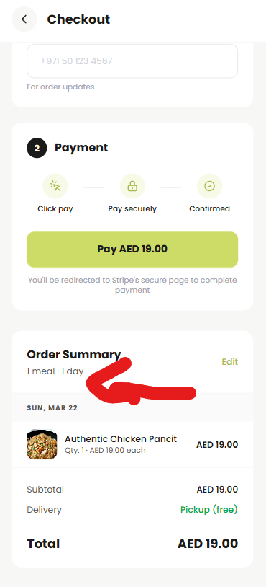
- Important we store in the backend all transactions with
  - Email address
  - Name
  - Phone
  - Date and time stamp
- Need to split out the 5% VAT from the total
  - 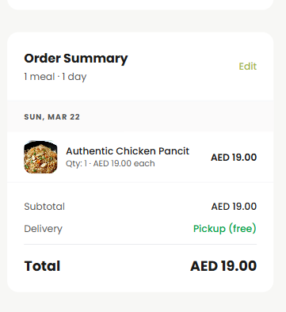
- Remove the repeat button
